Define a String Variable
Let's start by creating a variable containing a long file path. We will use this string to practice our manipulation techniques.

String handling appears everywhere in shell work because so much system information is represented as text: paths, usernames, hostnames, configuration values, and command output. Learning to reshape text without leaving the shell is a major productivity gain.

Create a new script named string_lab.sh.

Open string_lab.sh and add the following code:

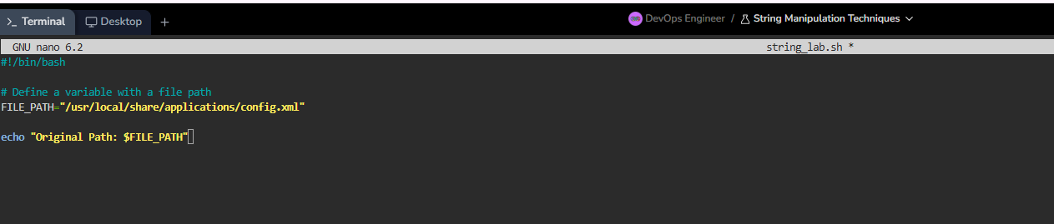
Expected output:
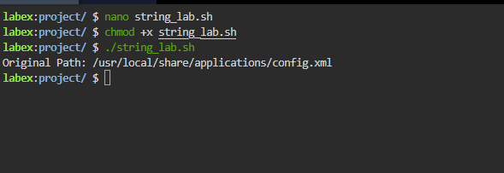
Extract a Substring (Slicing)
Sometimes you only want a specific part of a string, such as the first few characters. This is called Slicing.

The syntax for slicing is: ${Variable:Offset:Length}
Offset: Where to start (0 is the first character).
Length: How many characters to take
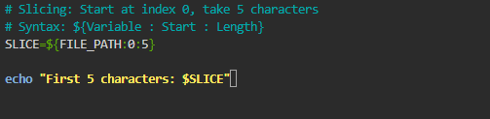
Expected output:
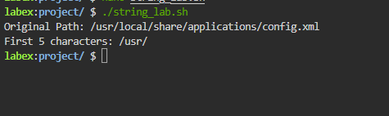
Replace a Substring
This technique works like "Find and Replace" in a text editor.
The syntax is: ${Variable/Find/Replace}.
Let's say we want to change the folder share to bin in our file path.
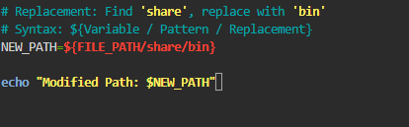
Expected output:
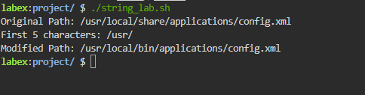

Provide a Default Value
Scripts often rely on inputs or environment variables (like USER or HOME). If these variables are missing, your script might crash or behave unpredictably.
You can provide a Default Value to be used if the variable is unset or empty.
The syntax is: ${Variable:-DefaultValue}.
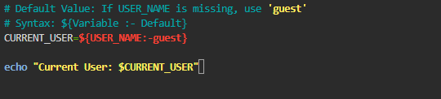
Expected output:
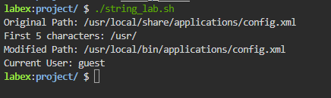
Summary
In this lab, you learned how to manipulate strings directly within Bash using Parameter Expansion:
Slicing (${var:offset:length}): Extracting precise substrings.
Replacing (${var/old/new}): modifying the content of a variable.
Default Values (${var:-default}): Handling missing variables gracefully.
These techniques allow you to write robust scripts that can handle text processing efficiently without needing external tools like sed or awk for simple tasks.

